Handing over Ndemban Healthcare Centre by UNDP and the World Bank to the Government of The Gambia

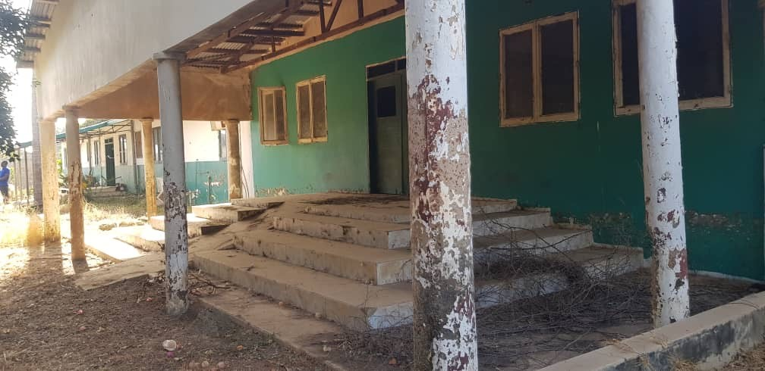
Banjul, Dec 5, 2020 – When Covid-19 cases rose exponentially in July Hospital it became apparent that additional health care facilities were necessary to address urgent needs.

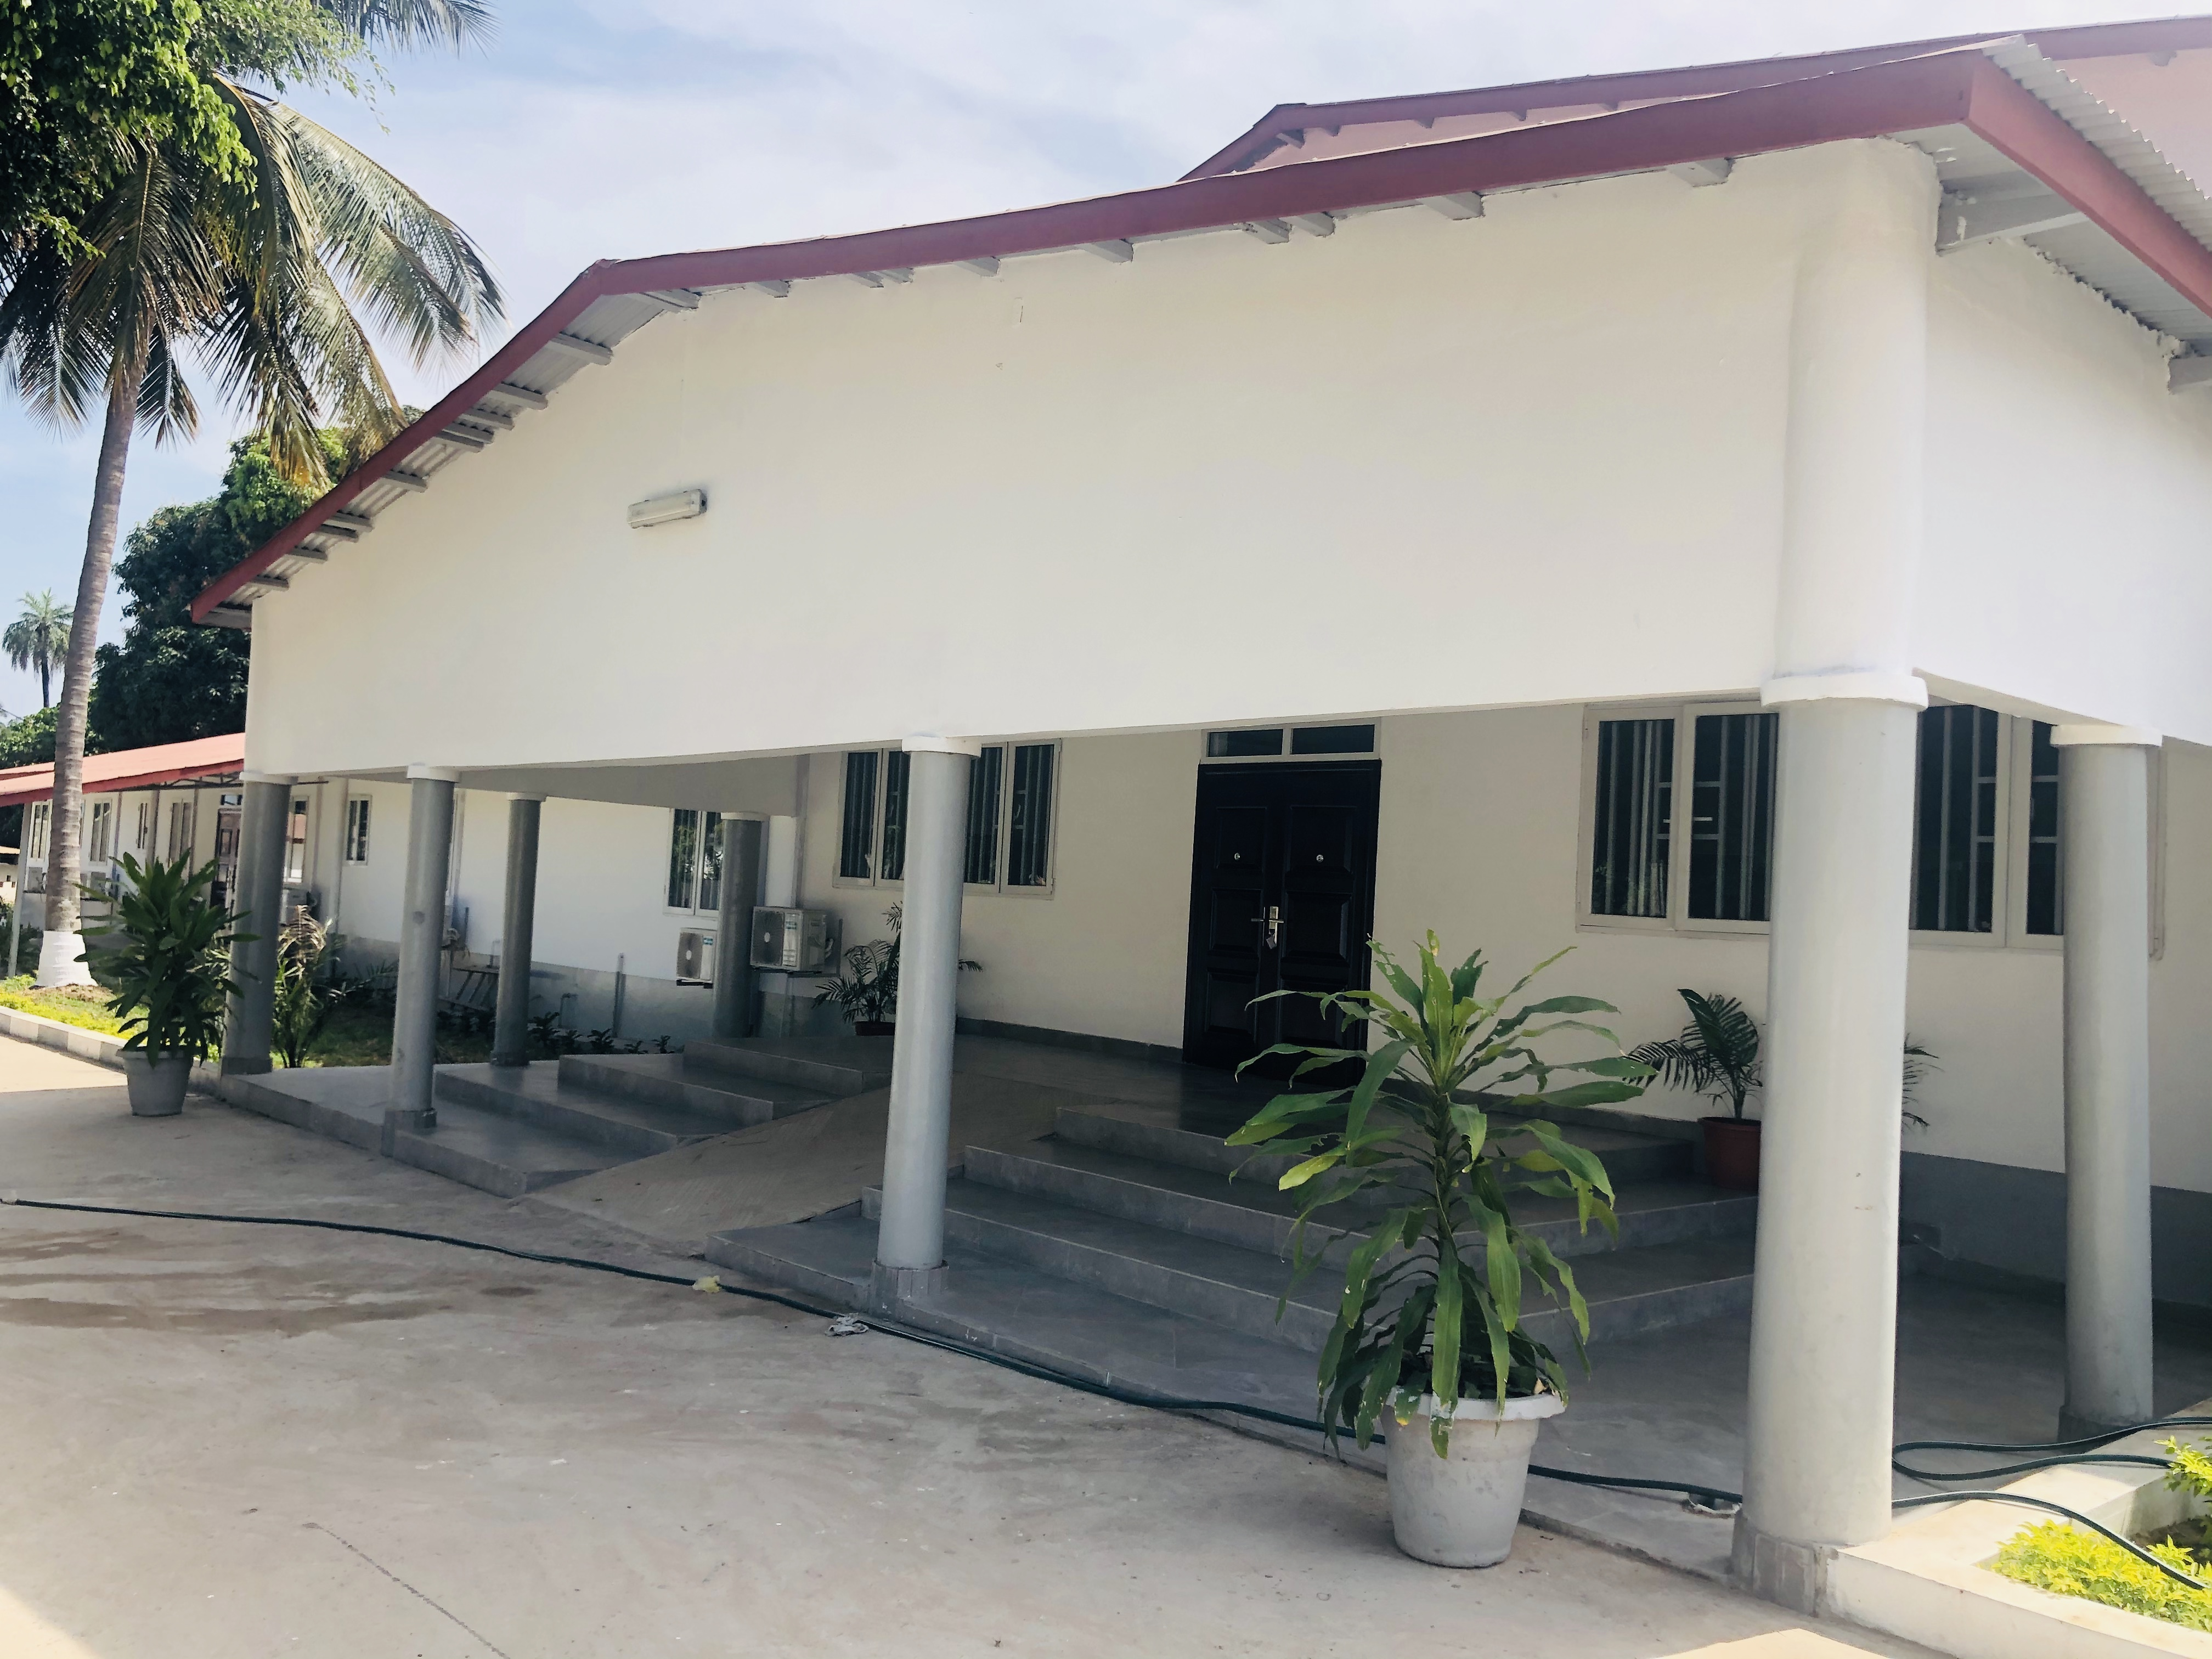
In response, a Public Private Partnership (PPP) cooperation between the Ministry of Health of The Gambia, World Bank, UNDP and TAF AFRICA GLOBAL (GAMBIA) LTD was developed to rehabilitate the abandoned Ndemban Healthcare Centre. UNOPS also provided technical advisory support. Ndemban will host several healthcare departments to decongest the Main Hospital.

His excellency, President Adama Barrow and Dr. Ahmadou Lamin Samateh, Minister of Health visited the facility on 27 October 2020 and expressed satisfaction with the transformation and rehabilitation of the building into a modern health center. The Ndemban Center will contribute in enhancing the health system, improve people’s access to adequate health care and #BuildingForwardBetter #TheGambiaBeyondCovid

For more information and media interviews, contact: Mariam Njai, Communications Analyst, UNDP The Gambia: Tel; +220 3303180, Email: mariam.njai@undp.org. Facebook: @UNDPGambia | Twitter: @UNDP_TheGambia

